RESUME

 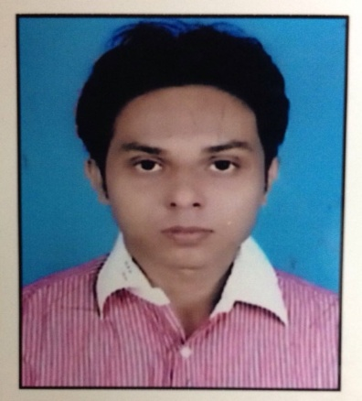

Prasenjit Ghosh   
  
prasenjit253@gmail.com  
  
+919038105073

* Objective: “Seeking a position in an office environment, where there is a need for a variety of office management tasks including – computer knowledge, organizational abilities, business intelligence and database program use.”
* Academic Qualification

|  |  |  |  |
| --- | --- | --- | --- |
| Examination | Board/University | Year of Passing | Percentage |
| PGDM | Asian Business School, Noida | “Pursuing” | Nil |
| B.COM (HONS) | West Bangal State University, Kolkata | 2012 | 42 |
| 12th | WBCHSE | 2009 | 62 |
| 10th | WBBSE | 2007 | 59 |

* Experience
* Worked as a freelancer in Direct Sales in Garments Sector for 1 year and 2 months (February, 2016 to March, 2017).
* Worked as an Intern in Indian Oil Corporation Ltd (Marketing Division, Noida, UP) for 6 weeks ( May, 2016 to June, 2016).
* Worked as a Freelancer (SEO Expert, Conversation with client) for 1 year (December, 2013 to November, 2014).
* Worked as a BDE and SEO & SMO Expert in Web Care InfoTech for 1 year and 2 months (October, 2012 to November, 2013).
* Corporate Interface
* Attended the workshop named “Think Big” presented by Richa Sharma.
* Achievements
* Played football for State Football Team U-19 (Bengal).
* Skills
* Interpersonal
* Hard worker.
* Disciplined.
* Determined.
* Technical
* Computer Basic Knowledge & Hardware Maintenance.
* Personal Details

Name - Prasenjit Ghosh

DOB - 17.01.1991

Address - Bidhanpally, Battala Kalibari  
 Madhyamgram, Kolkata,  
 West Bengal.

Father’s Name - Proloy Kumar Ghosh

Email id - prasenjit253@gmail.com

Phone No - +919038105073, +919830517171

Interest - Playing Football, Adventure.

* Declaration :

I hereby declare that the details provided above by me are true to the best of my knowledge.

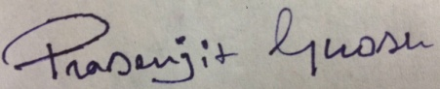

(Signature)